Alexander, Mills

Dr. Pawar

STATS 341

15 September 2023

The difference between Standard Deviation and Variance

When talking about Standard Deviation and Variance, they are both a form of analyzing data and its outliers from the overall average. The main difference is that one stays in the same units when expressing the data and the other does not.

Standard Deviation is the analysis or measurement of how far data is away from the average set of data. For example, when looking at a graph, if a large amount of data is cluster together, that would be consider the mean. Data that is father way from the large cluster of data are known as outliers and measuring how apart that data is from each is the standard Deviation. If we look at a normal distribution graph, then the points of data outside of the graphs range. This form of analysis is normal used when you want to use the same units that are used in the data set.

Variance is the measure of the average of how far apart the data is spread out from there average value more known as the average of the squared differences from the mean. This form of analysis is not expressed in the same units as the data since the differences are squared. The difference in the formula of Standard Deviation and Variance is that variance is the standard deviation squared.

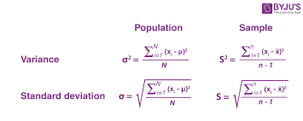

[**https://byjus.com/maths/variance-and-standard-deviation/**](https://byjus.com/maths/variance-and-standard-deviation/)

**Xi represents the induvial population value, X is the sample average, n is the total number of samples.**